I attached the 3929 GWS concentration code as Rule Based on program code 20GF4019BS in BANDEV. This existing program code has a Major Dependent attached concentration.

First step is to show the Field of Study block on the Curricula tab of SGASTDN. This is where a user needs to insert a new Concentration Field of Study row because the major dependent concentration didn’t get attached in Admissions.
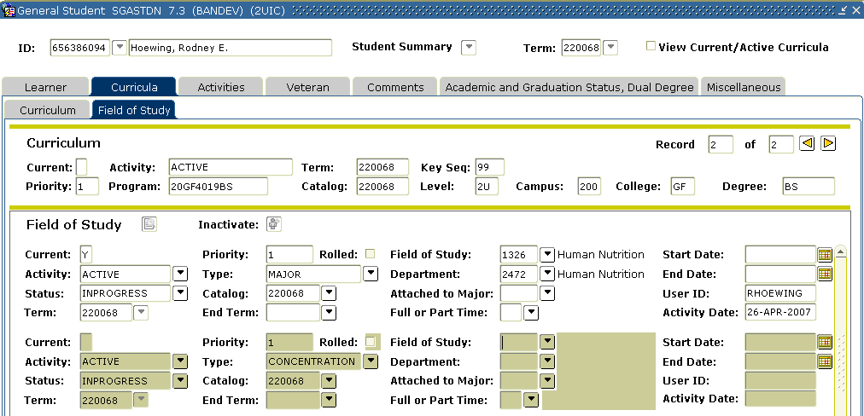
User would click on the drop down button next to the Field of Study field to provide a list of values. The user gets a pop-up window that looks like this:
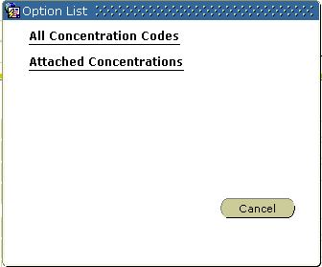
The user would then select the Attached Concentrations link and the following pop-up window would appear:
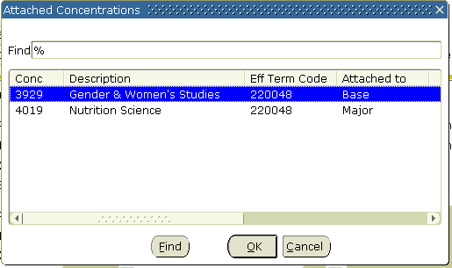

The list of values actually states whether the concentration you want to select is Attached to Base or Attached to Major. I selected the concentration attached to the Major first because it is important to have that concentration on the student’s record.

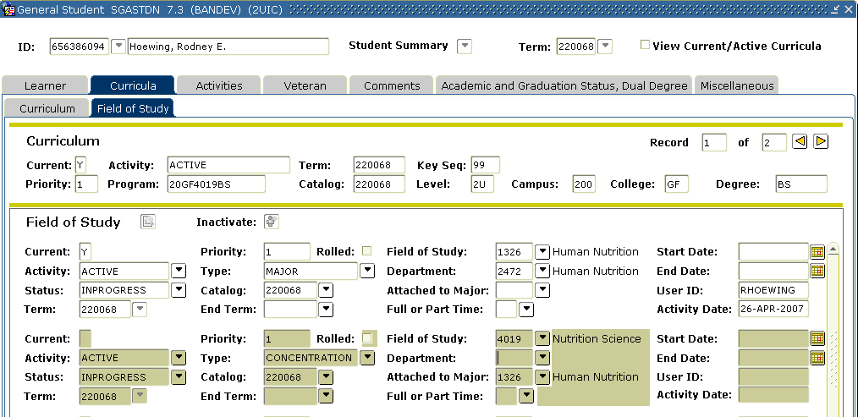
As you can see here, the Attached to Major field was automatically populated with the major code of Human Nutrition. This is how you can tell on the SGASTDN record that the concentration is attached to the Major. This will be important later as I show the transcript.

Now, we will add another concentration Field of Study row to place the GWS concentration on the SGASTDN record.
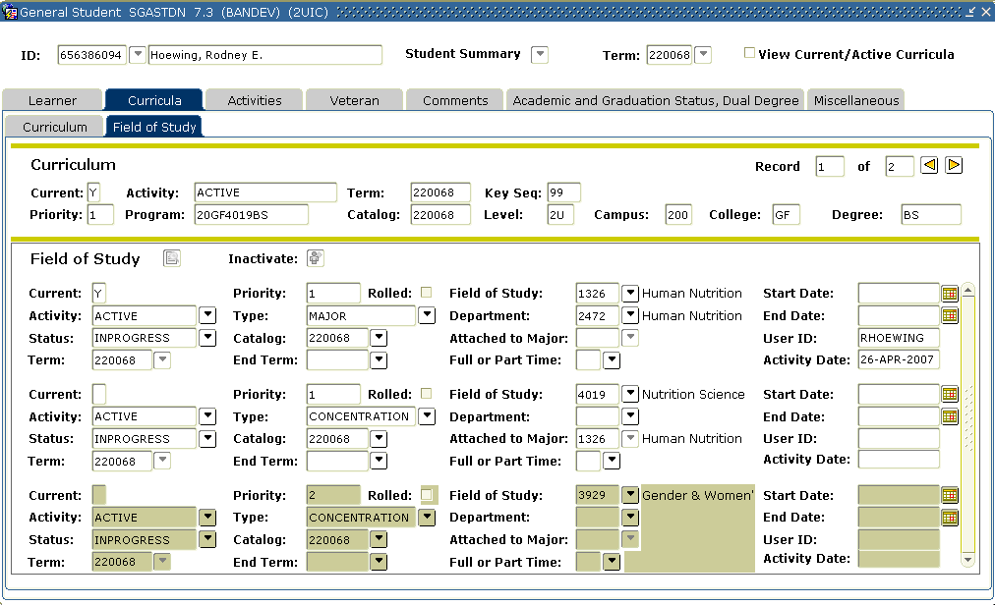
The Gender & Women’s Studies concentration has the Attached to Major field left as null.

This student now has a Major Dependent Concentration and a Rule Based Concentration attached to the SGASTDN record. I also added a Minor of Business Administration to the Student record and created an Awarded degree all with the same major, minor and concentrations. Here is how the transcript looks:

Student No: 656386094 Date Issued: 26-APR-2007

Record of: Rodney E Hoewing U N O F F I C I A L Page: 1

Course Level: Undergrad - Chicago

Current Program
College : Applied Health Sciences
Major : Human Nutrition
Maj/Concentration : Nutrition Science
Minor : Business Administration
Concentration : Gender & Women's Studies

Degree(s) Awarded Bachelor of Science
Primary Degree
College : Applied Health Sciences
Major : Human Nutrition
Maj/Concentration : Nutrition Science
Minor : Business Administration
Concentration : Gender & Women's Studies

SUBJ NO. COURSE TITLE CRED GRD PTS R
_________________________________________________________________

INSTITUTION CREDIT:

Fall 2006 - Chicago
Applied Health Sciences
Human Nutrition
BIOS 475 Neural Engineering I 3.00 B 9.00
Ehrs: 3.00 GPA-Hrs: 3.00 QPts: 9.00 GPA: 3.00

********************** TRANSCRIPT TOTALS ***********************
Earned Hrs GPA Hrs Points GPA
TOTAL INSTITUTION 3.00 3.00 9.00 3.00

TOTAL TRANSFER 0.00 0.00 0.00 0.00

OVERALL 3.00 3.00 9.00 3.00
********************** END OF TRANSCRIPT ***********************

